Setting up a new hosting user though Plesk

- Logon to Plesk
  - https://66.29.18.65:8443/login.php3
  - Login: Admin
  - Password: R@t1ng
- Add a new Client
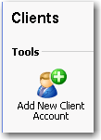
- Enter in the Clients information
  - Company Name: Company Name
  - Contact name: <Client Name> - <Plan Symbol> - <ClientID>
e.g. Adam Cogan - G - SSW
  - E-mail: DON’T ENTER AN EMAIL YET
  - Template: <Choose the plan they are on>
- Leave the default for the IP pool.
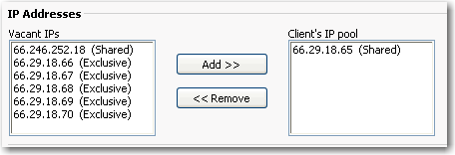
- Add a new Domain

- Enter in the Domain information
  - Domain Name: <domain name of the customer> e.g. SSAYouth.com
  - Template: ALL
- Enter in the Physical hosting information
  - FTP Login: <The same login you used previously>
  - Password: <The same password you used previously>
  - Hard disk quota: <The hard drive space they have got>
This information is in the Template you choose earlier however we have to do it again for some reason. This is the figure that gets set in Serv-U. This makes sure that the user cannot upload more than they have.
- Now that the account has been created
- Go back to the client record and Click on the Edit link

- Now enter in there E-Mail Address. (we enter it in after so the initial email does not get set to the customer. We send them an email later)

- Done.
Now send them the SSW Diary template for the hosting plan they selected.

